

**BLG 477E**

**MULTIMEDIA COMPUTING**

CRN: 22539

INSTRUCTOR: HAZIM KEMAL EKENEL

**ASSIGNMENT #1**

**Canny Edge Detector**

Submission Date: 20.03.2015

STUDENT NAME: TUĞRUL YATAĞAN

STUDENT NUMBER: 040100117

# Introduction

In this project Canny Edge Detector algorithm is implemented with MATLAB. Algorithm has six stages;

1. Convert to Grayscale
2. Smoothing
3. Finding gradients
4. Non-maximum suppression
5. Double thresholding
6. Edge tracking by hysteresis

These steps are done in canny.m source file consecutively with MATLAB. There are two auxiliary functions in source file for Gaussian filter calculation and convolution.

# Development and Operating Environments

MATLAB R2012b has been used on Ubuntu 14.04 operation system.

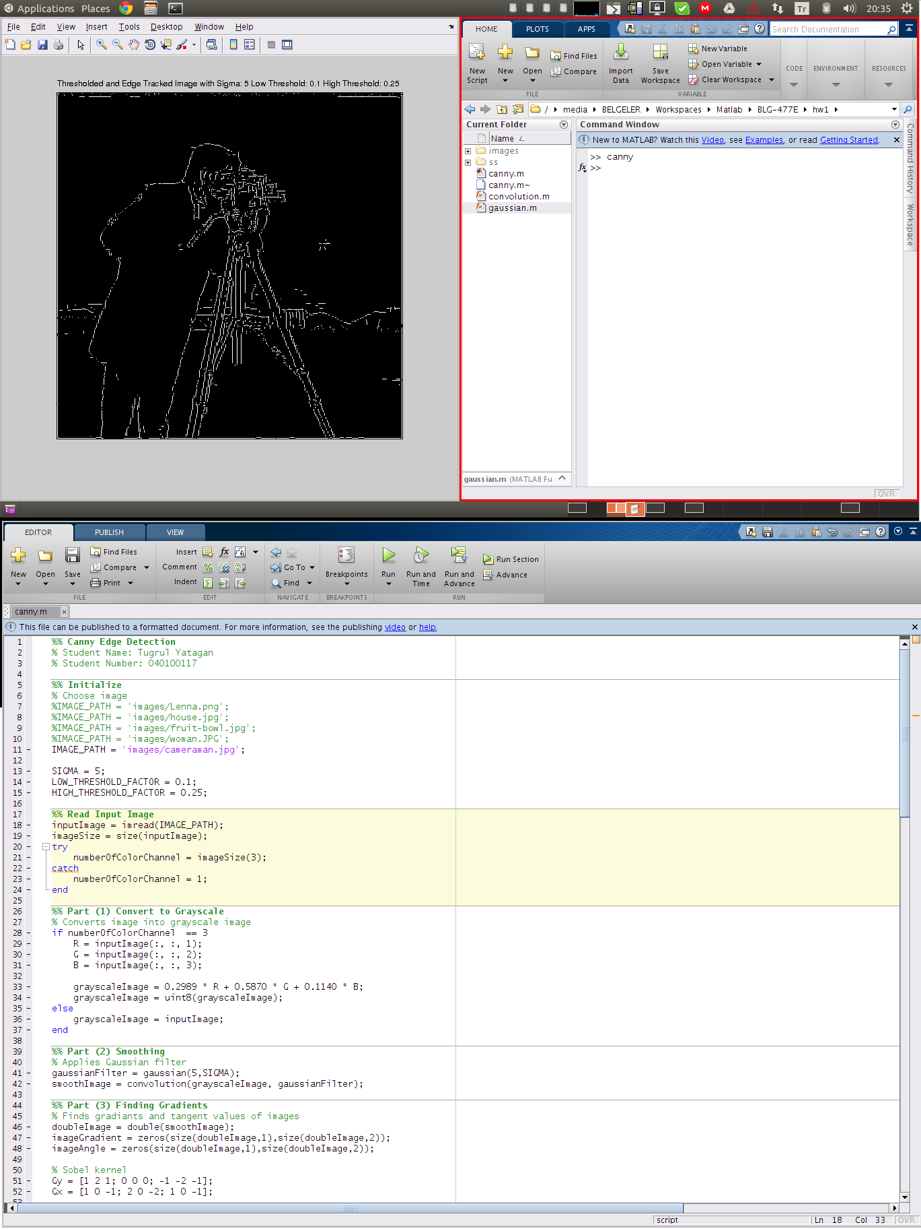

# Analysis of Canny Algorithm Stages

Canny Edge Detector algorithm stages analysis will be done with Lena image. All images are taken from MATLAB canny.m application with different stages.

## Grayscale

RGB to grayscale image is below.

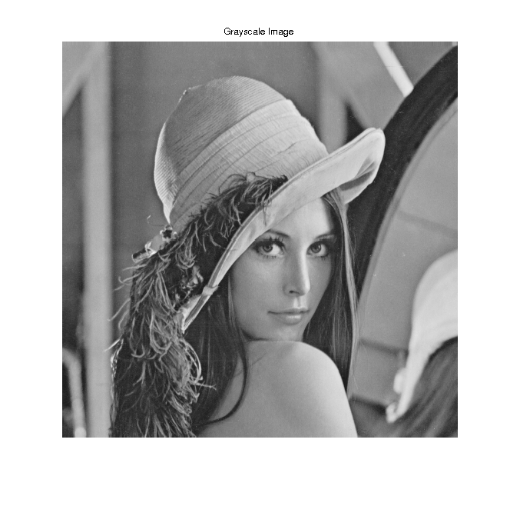

## Smoothing

Gaussian filtering images with different Gaussian sigma values are below. Blurring increases when sigma increase.

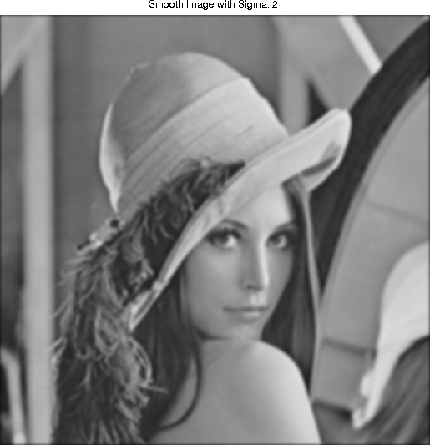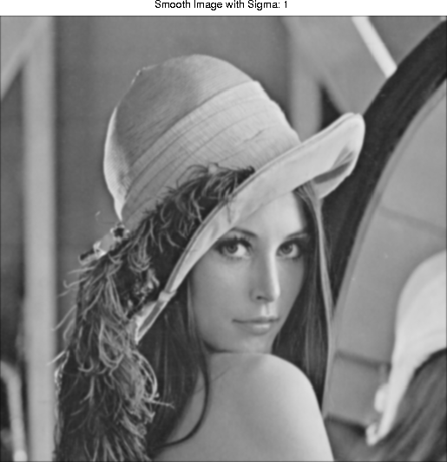

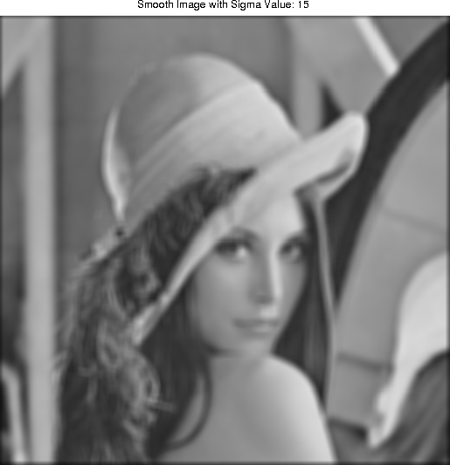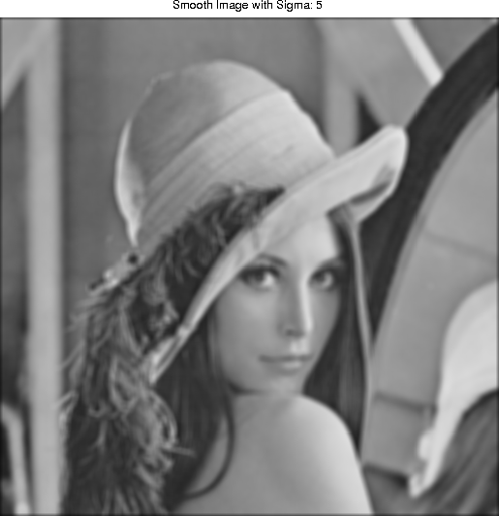

## Finding Gradients

Total magnitude of X and Y gradients image with Gaussian sigma value 1 is below.

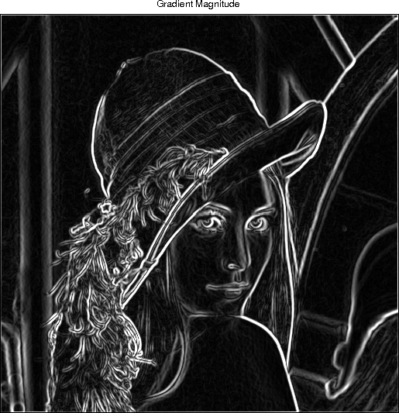

## Non-Maximum suppression

Non-Maximum suppression image of magnitude gradient image with Gaussian sigma value 1 is below.

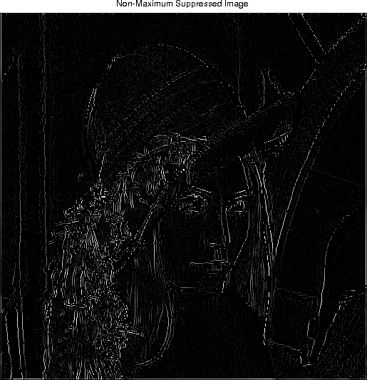

## Double Thresholding and Edge Tracking by Hysteresis

Thresholded and edge tracked images with different Gaussian sigma, low threshold and high threshold values are below. Default Gaussian sigma value is 1 unless otherwise is stated. Low and high threshold values are relative to the image. Low and high threshold values are multiplied with maximum pixel value of images after non-maximum suppression.

**Gaussian sigma value: 1, low threshold value: 0.1**

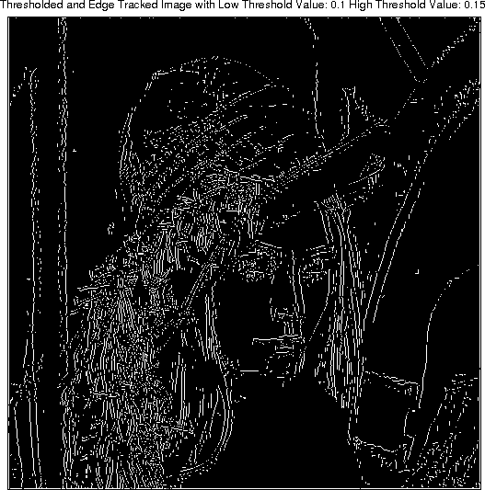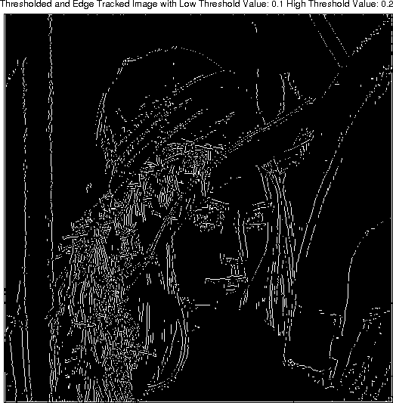

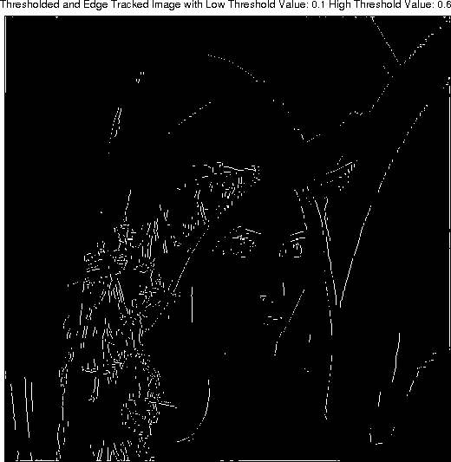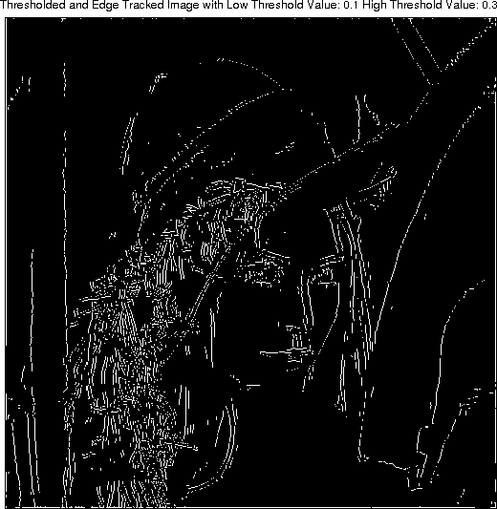

**Gaussian sigma value: 1, low threshold value: 0.2**

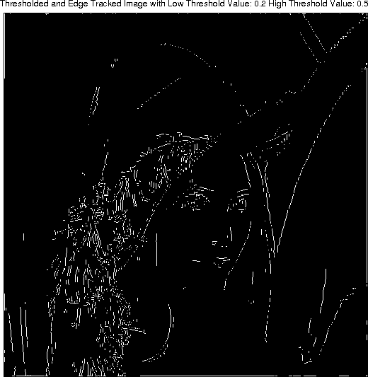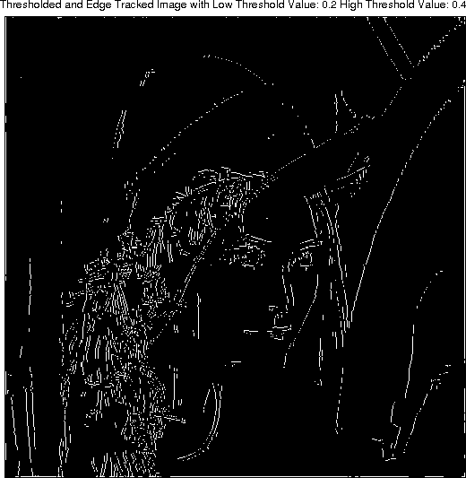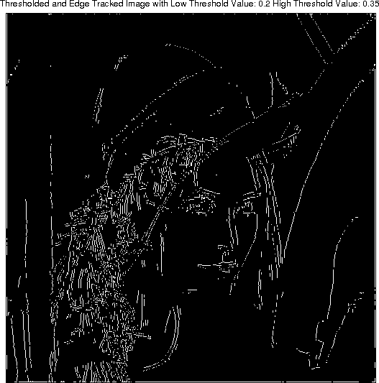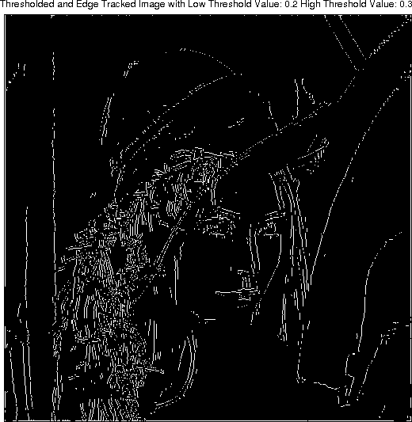

**Gaussian sigma value: 1, low threshold value: 0.25, high threshold value: 0.3**

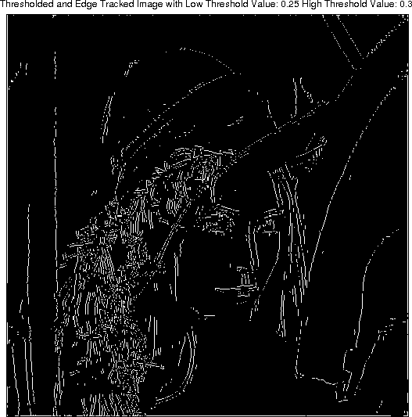

**Gaussian sigma value: 1, low threshold value: 0.3, high threshold value: 0.5**

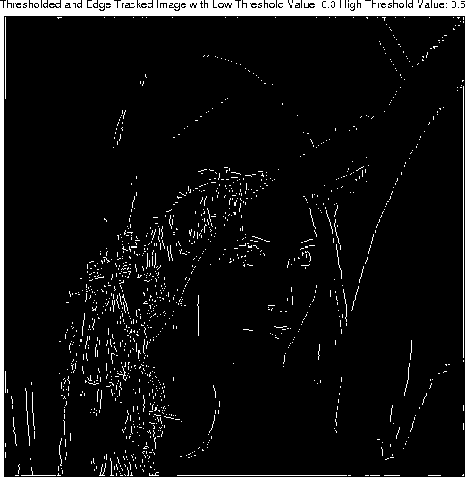

**Gaussian sigma value: 2, low threshold value: 0.2, high threshold value: 0.25**

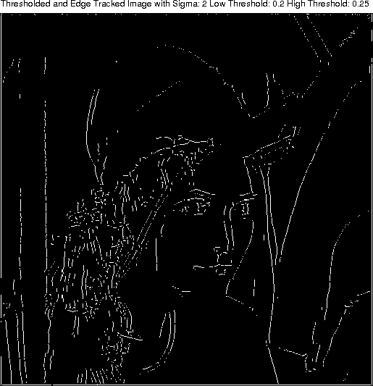

# Final Results of Other Images

**Cameraman; Gaussian sigma value: 5, low threshold value: 0.1, high threshold value: 0.25**

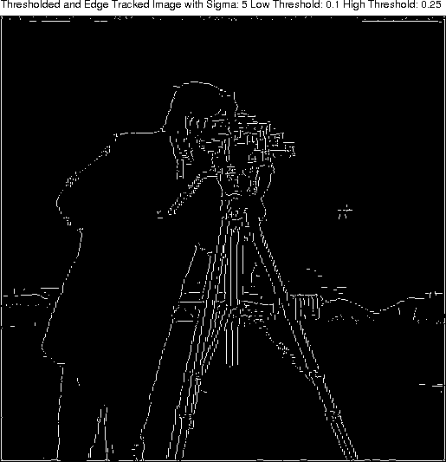

**Fruit bowl; Gaussian sigma value: 1, low threshold value: 0.2, high threshold value: 0.3**

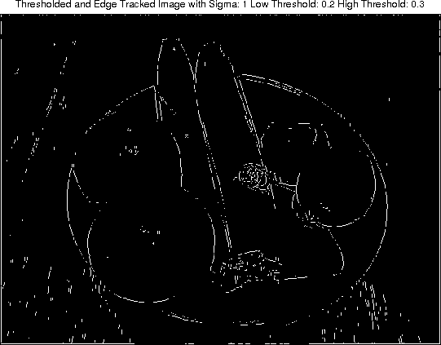

**House; Gaussian sigma value: 1, low threshold value: 0.1, high threshold value: 0.25**

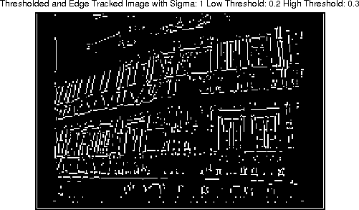

**Woman; Gaussian sigma value: 2, low threshold value: 0.2, high threshold value: 0.3**

